**Intro to Web Dev Final Report Template**

**Directions:** Follow the directions according to the Touchstone Instructions document. Include your responses for all the sections listed under the Directions section. Remember to review the Touchstone instruction page for entry requirements and grading specifics.

**Name: Monet Paul**

**Date: 01/22/2024**

**Final Program Share Link from the IDE: https://stackblitz.com/edit/book-haven-bookstore1**

# **Introduction**

**Client name: Book Haven Bookstore**

This report will cover the structures, design and website functionality for the client’s website. For the Client “Book Haven Bookstore”, they are a bookstore wanting an online presence to reach and connect with more readers. The client expressed that they want their website to have a theme of celebrating written words and to have a digital space that also embraced literary discovery and support the growth of intellectual enhancement which was the focus of the Web design.

* Color palette choice: Color Palette 2 was picked for the palette of the website. Each color in this palette given literary vibe and growth theme. The other color palettes are inappropriate for the target audience. In Color palette 1, the colors are more generic and don’t fit the theme of literary discovery. In Color palette 3 is more set for children and fictional readings. The client is selling books to more for a broad audience. Each colors betrayed a basic book cover or book’s categories. For #742C36(Romantic Red) in the color palette, I can see Romantic books section of a bookstore or library. Looking at this palette, it given off growth with literature which suited supporting role, the client wants to capture for their brand.
* Logo choice: *Logo 3 (Literature Blue #3F5461) was pick because in palette had both green and red which can be hard to see for color blind people. Also, I thought about the word “*Haven” in the store title. We already have a book and a plant in the logo to bring literary discovery, and intellectual growth. *The only thing missing is support and encouragement.* I wanted to bring these elements with this color choice for this client
* Font color choice: Font color 2 (Bookish Black #131C26) was chosen because it has high contrast from white from the other choices which contrast ratio is **17.19:1.** Also, it’s not pure black which fits the best practice for using black.
* Typography choice: The reason for picking typography option 3 because it fit the client’s desire theme when they said “celebrating written words”. They are very clear and easy to read. There typographies give the literature vibe of old school books and scripts.

# **Wireframes**

1. **Mobile Wireframes:**

<Include the screenshots for the mobile wireframes for the Homepage, Gallery page, About Us page, and custom page>

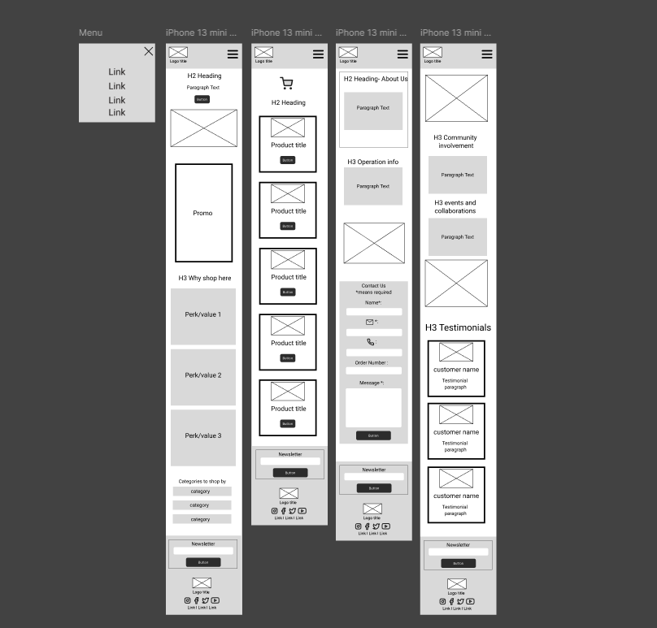

<https://www.figma.com/design/aiCMplthPt6agmlsPoRnsQ/Mobile-Wireframe--Book-Haven-Bookstore?node-id=15-243&t=cXhh6O8AuVKzxpfc-1>

1. **Desktop Wireframes:**

<Include the screenshots for the desktop wireframes for the Homepage, Gallery page, About Us page, and custom page>  
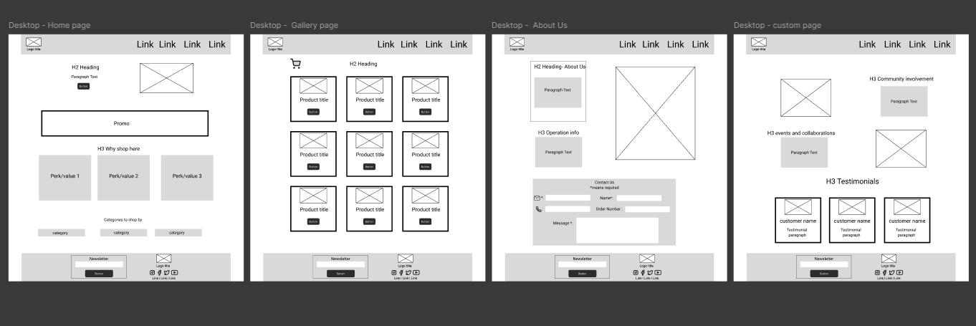

https://www.figma.com/design/4WVtZBLWe2OvU00bu9d3Ah/Desktop-Wireframe--Book-Haven-Bookstore?node-id=0-1&t=KraOGLI0W8lSnzrP-1

# **Website Structure and Content**

The website has 4 webpages which are Home, Galley, About, Custom page. All 4 have the navigation bar and footer.

The navigation bar has the logo with title of the store name on the left and the menu on the right with all of the nav links.

The footer has the newsletter feature on the left and logo with title of the store name on the right and under the store title is social media links. Then under the social media links is the footer links to the other webpages of the site. After the newsletter feature and everything on the right-side is the copyright label for the client.

**1) Home Page:** **https://stackblitz.com/edit/book-haven-bookstore1?file=index.html**

The home page has 4 sections.

* The first section or hook section welcome the customer to the website and action button to view our gallery pages.
* The second section or promo section shows all the store’s offers and action button to view our gallery pages
* The third section shows the store’s values/perks.
* The last section is the categories sections where it shows the different categories to shop by.

**2) Gallery Page:** https://stackblitz.com/edit/book-haven-bookstore1?file=shelf.html

The Gallery page have cart button to view the cart which will pop up other display. Products section with all of the products group together. Each product has an image with a brief description and title. Each also have button to add to cart.

**3) About Us Page: https://stackblitz.com/edit/book-haven-bookstore1?file=About.html**

The about us page have two sections. The first one is more some information about the store and the second one is the contact form for the customer to enter their information.

**4) Custom Page:** https://stackblitz.com/edit/book-haven-bookstore1?file=custompage.html

The custom page has 3 sections. The first section is about the store community involvement. The next section is about the Community Events the store offers. The last section is the customer testimonials.

# **Website Design and Styling**

1. **Overall Design:**

<Describe how the website design and styling follow the style and theme of the client. Include details about the colors choices you made for different sections (header, footer, and body) and how components of the webpages conform to your selected color palette, fonts, and typography choices.>

The website design and styling follow the style and theme of the client wanted. For the different sections, the colors used are from the color palette chosen, font color, as well as basic colors that will contrast well with them and typography option. Next is the description in details of both the navigation bar and footer.

* The header and footer both have a gray background(#E0E0E0) and the links are the logo color(#3F5461). There is a hover effect on links where it gives an underline.
* The header has a display of flex where the logo and title are on the left. On the right is menu with all of the nav link. The logo is aligned center of the title and above the title. The title has display font which is Courier New Bold 40px.
* The footer has a display of flex where the newsletter feature is left and logo with title, social links, and footer links is on the right. logo with title, social links, and footer links was group together and give flex direction column with align them center. For the copyright label is font color option 2 and was center below and between the newsletter feature and the webpages links.

Next is different style for the web pages:

All Pages:

* For all the sections was set to display flex to give a unique layout with spacing. For all the buttons I made them the color of the logo with the white text. The buttons have hover effect where the colors invert. The text became the color of the logo. The background color is white with border of the color of the logo.
* All illustration images are from unDraw. The client wouldn’t have worry about any copyrights law sued or anything. This is Open-source illustrations.

Website: [unDraw - Open source illustrations for any idea](https://undraw.co/)

Link to License: [License | unDraw](https://undraw.co/license)

Home Page:

* Hook section is flexed with welcome introduction on the left and the illustration image on the right.
* Promo section and border line with this purple color (Regal Quill #5C2E5C) to grab the users attention. Certain keywords are changed to the purple color (Regal Quill #5C2E5C) as well to grab the user’s attention. The inside content is flexed with a gap. Each content has icon or image with a subtitle and description was flex in the direction of a column and center. Icons have the color of the logo. The image in the middle has a container which gives the image a max width of 200px. Then a call-to-action button where the user will be direct to our gallery page.
* The why us section is the same the promo but without the border line, purple font, and a call-to-action button
* The categories section is flexed with a gap. Each category has a purple background (Regal Quill #5C2E5C) with white text.

Gallery Page:

* All of the products are group together and are put in a grid which made them 3 by 3. Each product has image, title with short description which flex in column.
* The cart button is at the top on left. When the button is clicked, the cart/modal will be display as popup.
  + Cart/modal will be display none by default. Inside, it has a “X” button at the top on the right to close it out. It has a white background with two button which are “Clear All” and “Checkout”.

About Us Page:

* The illustration image and the information were flexed where image is on the right and the information is on the left. The information was broken into two sections where they flex in the column direction and center.
* The contact form was put in a grid to have it sit in a certain way.

Custom page:

* Community section was flexed with Involvements information, events information and two illustrations. Certain keywords are changed to the purple color (Regal Quill #5C2E5C) to grab the user’s attention.
* Customer testimonials section is flexed in row. Each testimonial has border line color of the logo, profile image, subtitle of name, and the paragraph of the testimonial. Each one is flex in columns.

1. **Accessibility:**

*To receive full credit, you will need to include at least three rationales for accessibility. Refer to Tutorial 2.4.5 for accessibility best practices and accessibility testing.*

For alt feature of the image tag, I made sure that every image ‘s alt was fill out for screen reader. I added auditory navigation marker as well. For font size, I use rem. I made sure the colors used was very contrast for white and gray color(#E0E0E0). I didn’t use the red (Romantic Red #742C36) or green (Book Worm #3E5641) to keep in mind of the color-blind population.

The colors that were under testing and used on the website are #E0E0E0, #3F5461, #131C26, #5C2E5C, #FFFFFF and the result said “No conflicts found. Swatches are color blind safe.”

1. **Responsive Web Design:**

*To receive full credit, you will need to include at least three RWD elements and rationales. Refer to Tutorials 2.4.6 and 2.4.7 for RWD.*

<describe responsive web design considerations in detail here>

I made two the media queries one for desktop and other for mobile. I adjust section to match the mobile platform screen by using the flex display and turn it in one column. I have two different menus for this website one for desktop and other for mobile. Mobile version has a hamburger menu button with modal to open the menu. I set Viewport to make everything fit on all screen.

# **Website Functionality**

1. **Navigation Bar:**

There are two different version of the Navigation bar for desktop and mobile version. Both have links to send the user to an Internal page of the website. Mobile version has a hamburger menu button with modal to open the menu.

1. **Subscribe Feature:**

The subscribe feature is in the footer of all pages. The feature has an input for the email and a button to submit. When a user entered their email address and click the button, they will get a window notification that they have been subscribed say “Thank you for subscribing”. When the user doesn’t enter their email address or they partially put it in, once they press the button, they will get notification that they need to put it in fully or just they need to put in their email address.

1. **Add to Cart Feature:**

The Add to Cart Feature is only in the gallery page. When a user clicks on add-to- cart button on one of items, the item will be added to the cart and they will get a notification that it has been added to the cart by the window saying “Item added to the cart”.

1. **View Cart Feature:**

The view cart feature is modal display window. When the user pressed the cart icon button, they will see the modal. In the modal, they will see what’s in their cart. There are two buttons at the bottom. The one on the left is clear all button to clear all of the items. If the user presses the button, it would say “Cart cleared”. The second one is checkout button to process the order and when the user press this button, it would say “Thank you for your order”. The user can close the modal by pressing the X icon button.

1. **Contact Us Feature:**

<describe website functionality in detail here>

The contact us feature has form where the user would fill fields: name, email address, phone number, order number and message. When the user fills out the form and click the submit button, they will get a pop-up message letting them know it was sent say “Thank you for your message”. Before the automatic validation there’s text at the top that shows what is required to help the user understand what is required for them to fill out and what is more so optional. Also, with the automatic validation this will help the user with what needs to be filled out just in case they did miss it.

# **Web Data Storage**

The website use data storage by integrates sessionStorage and localStorage in these two features below.

1. **Shopping Cart Feature:**

* When a user clicks on add-to- cart button on one of items, the item will be added to an array then add to the sessionStorage.
* When the user pressed the cart icon button to view cart feature, it will display cart data from sessionStorage in the modal window.
* The remove item feature is a remove button next to each item listed. When pressed, it will remove that particular item from the array then push to sessionStorage.
* Both the Clear cart and process order feature will remove all data from array and sessionStorage.

1. **Contact Us Feature:**

<describe your how your Contact Us feature uses data storage in detail here>

When the user fills out the form and click the submit button, all the data is put in object which holds the name, email address, phone number, order number and message. This object is then added to localStorage.

# **Customization**

<describe the custom page of your website in detail here>

The custom page is a community page to bring out the inviting digital space the client is look for. The page has several sections which are involvement, events and testimonials. This displays the client’s desire of a digital space where people can actually connect with the store on a deep level and can also join the community.

# **Screenshots of Rendered Webpages**

1. **Homepage**

<Include the screenshot(s) for the Homepage>

**Homepage:**

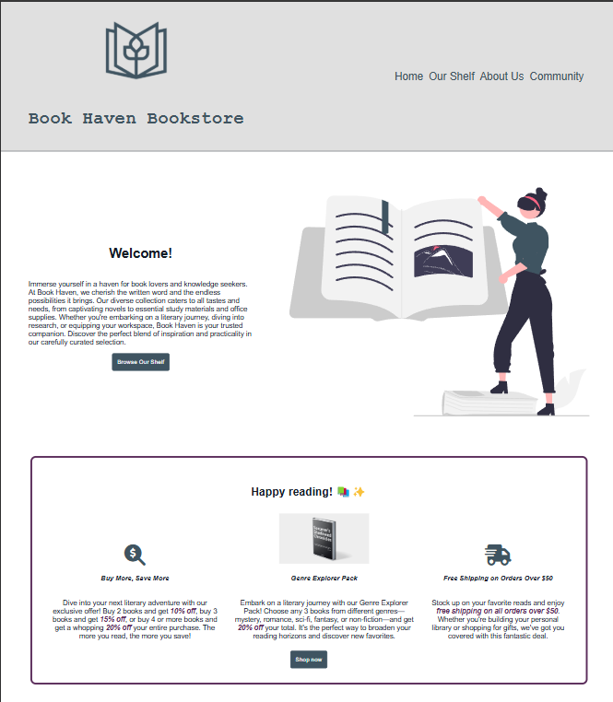

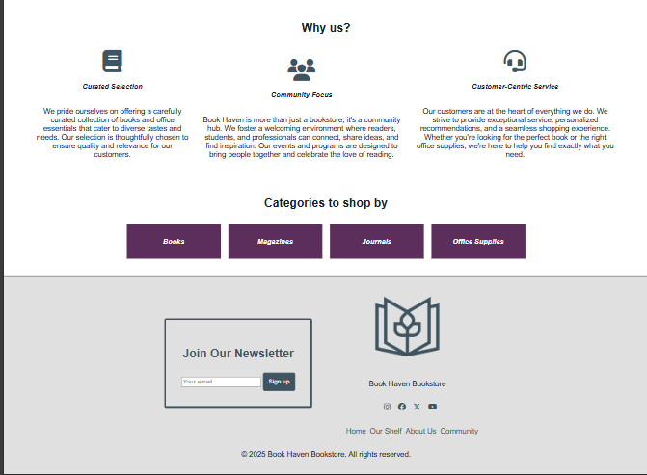

**Subscribe feature:**

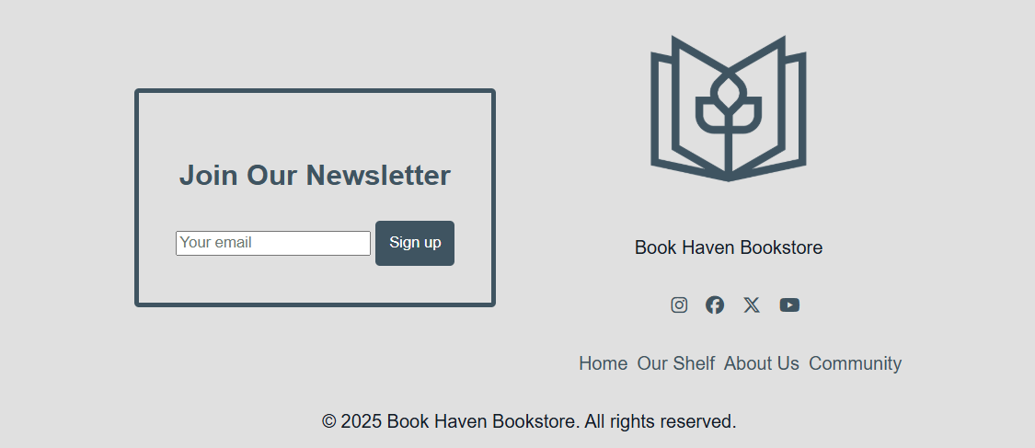

**Subscribe feature input validation:**

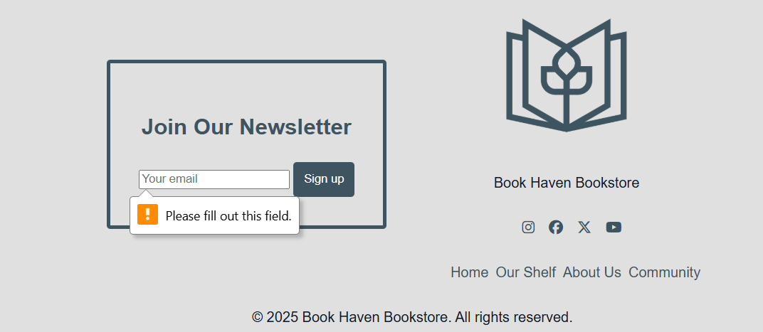

1. **Gallery Page**

<Include the screenshot(s) for the Gallery page>

**Gallery page:**

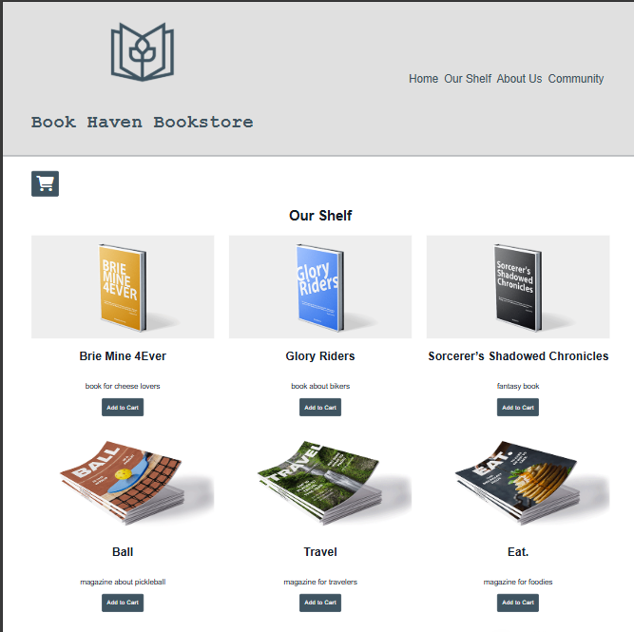

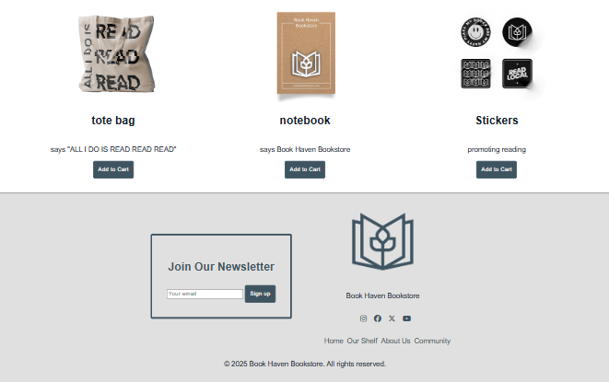

**Shopping cart—Add Item:**

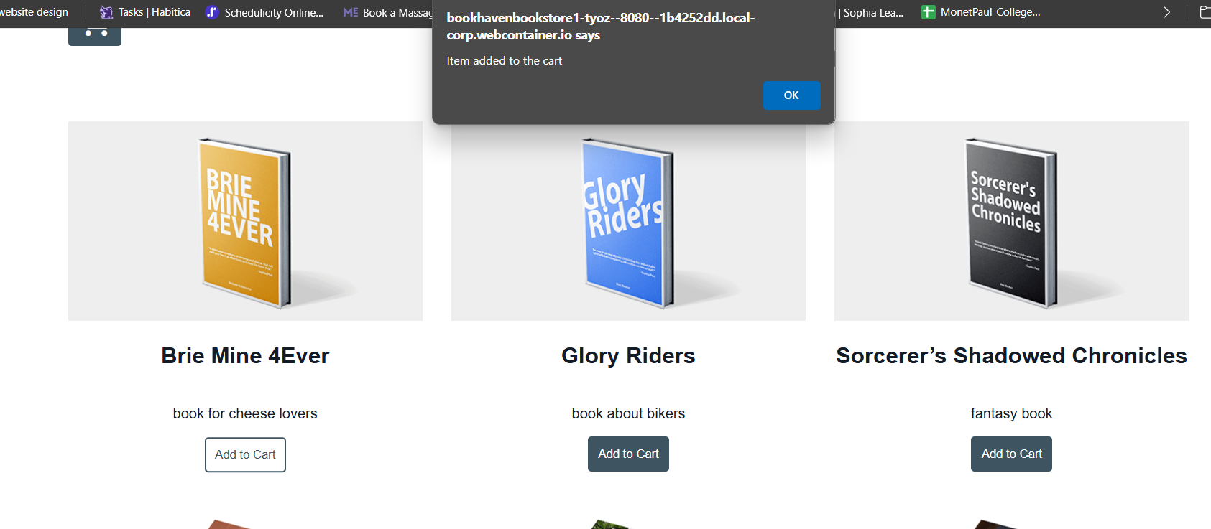

**Shopping cart—View Cart (after adding an item):**

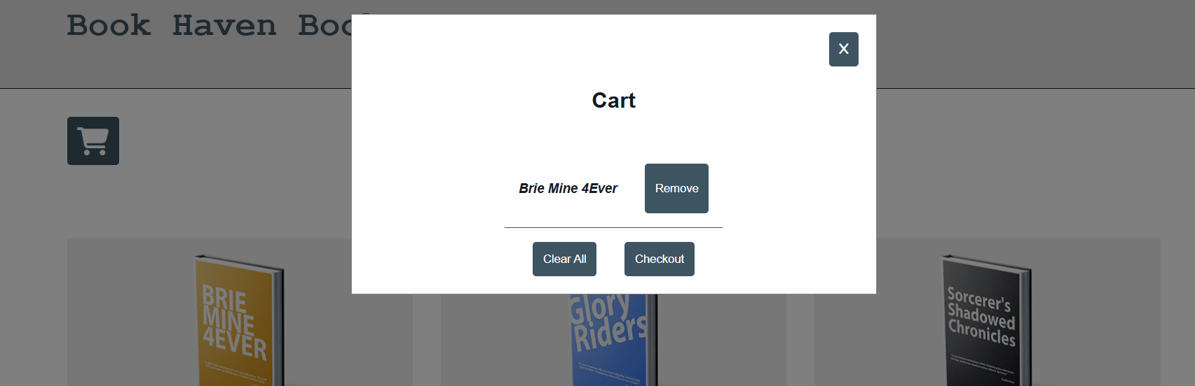

**Shopping cart—View Cart (after adding multiple items):**

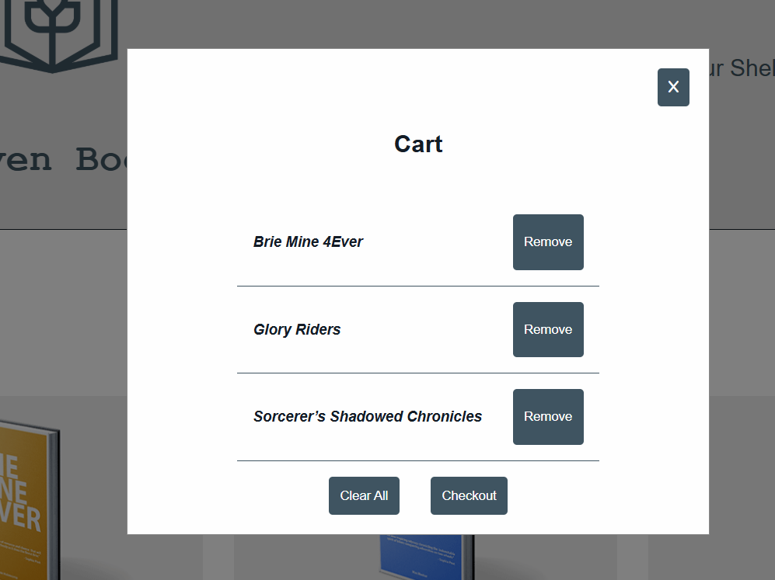

**Shopping cart—View Cart (alert message after “Clear Cart” button is clicked):**

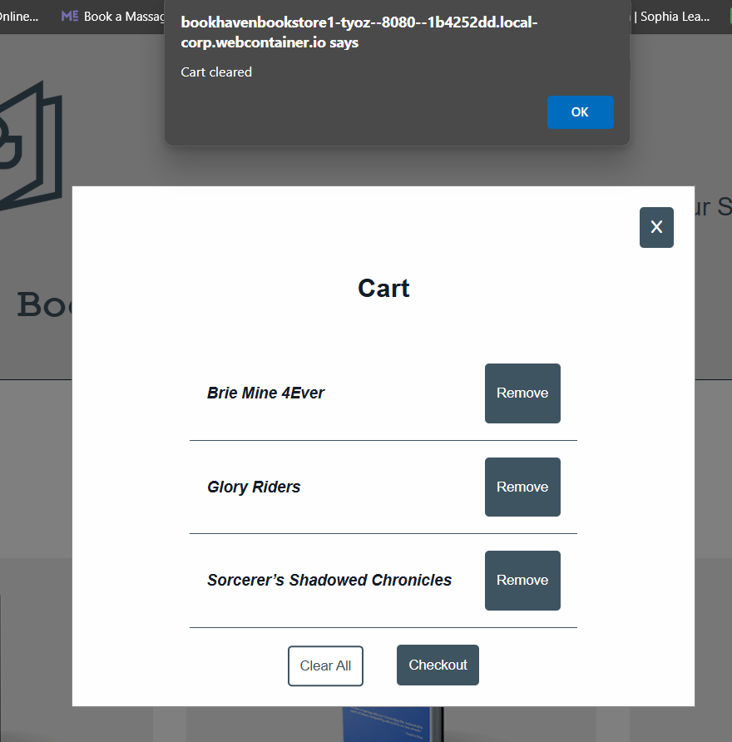

**Shopping cart—Process Order (alert after “Process Order” button is clicked):**

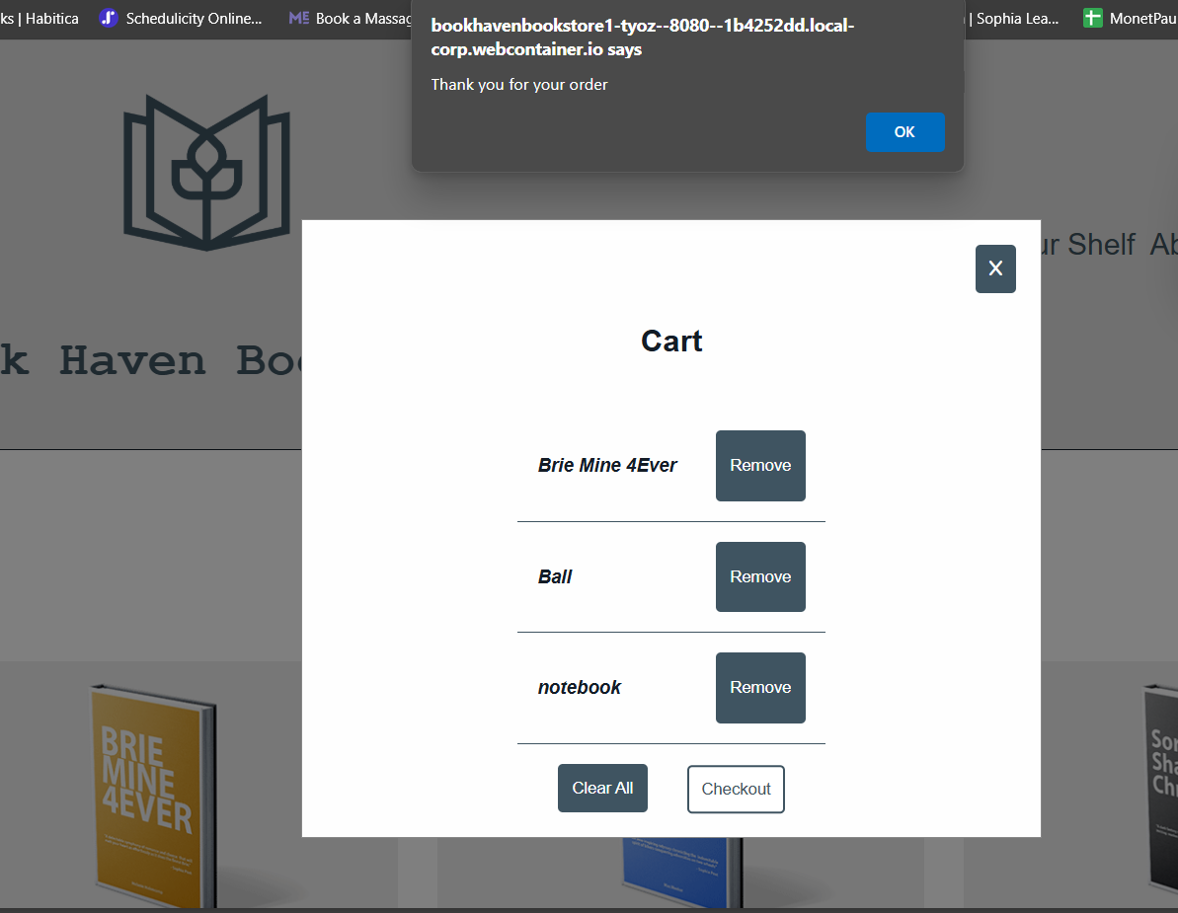

**Shopping cart—Process Order (alert after the order is already processed):**

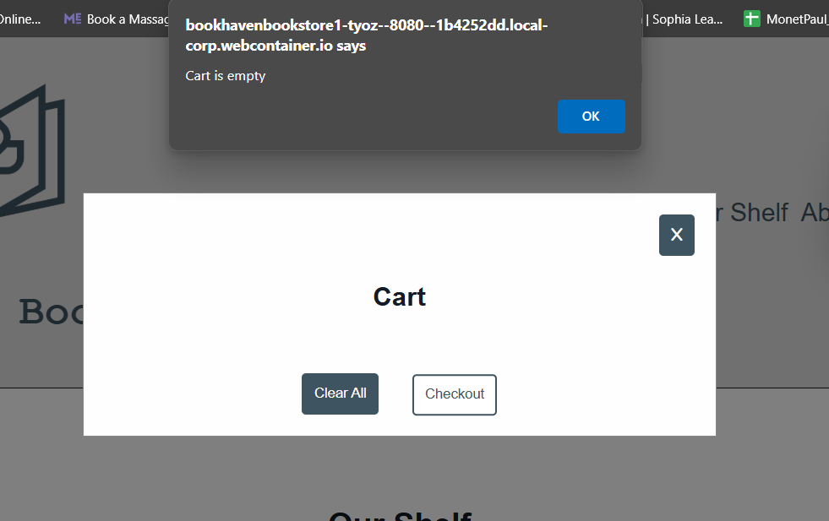

**Shopping cart—Clear Cart (empty cart):**

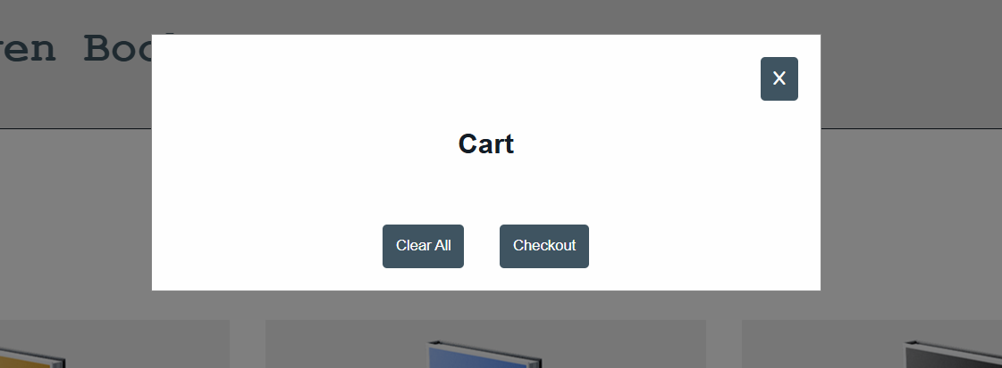

**Shopping cart—Clear Cart (alert window after clearing cart):**

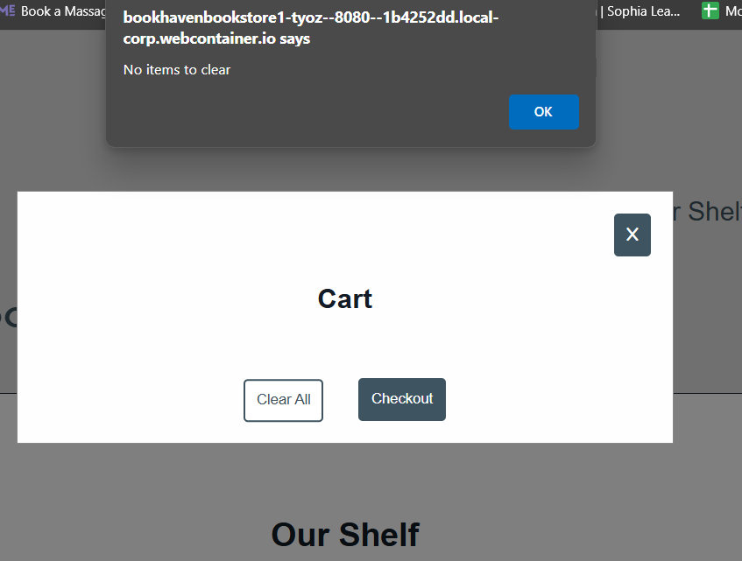

**SessionStorage (before processing order):**

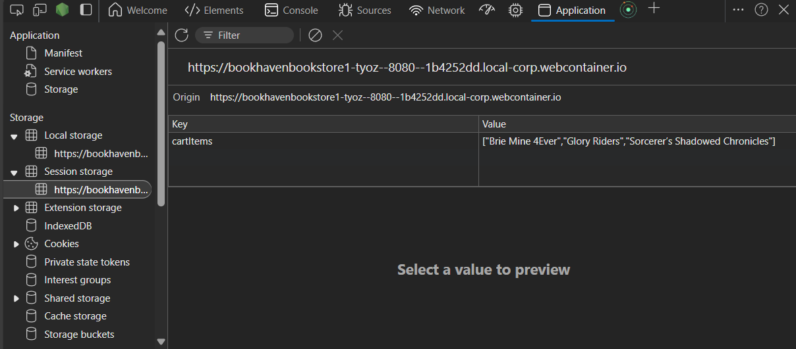

**SessionStorage (after processing order):**

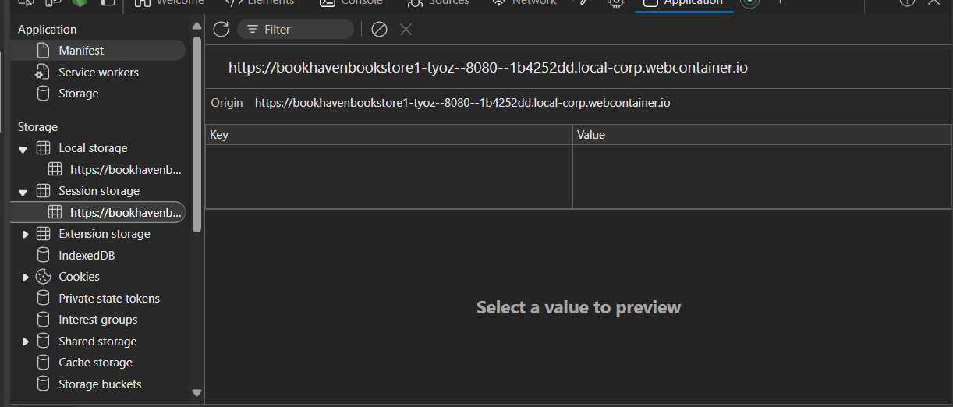

1. **About Us Page**

<Include the screenshot(s) for the About Us page>

**About Us page:**

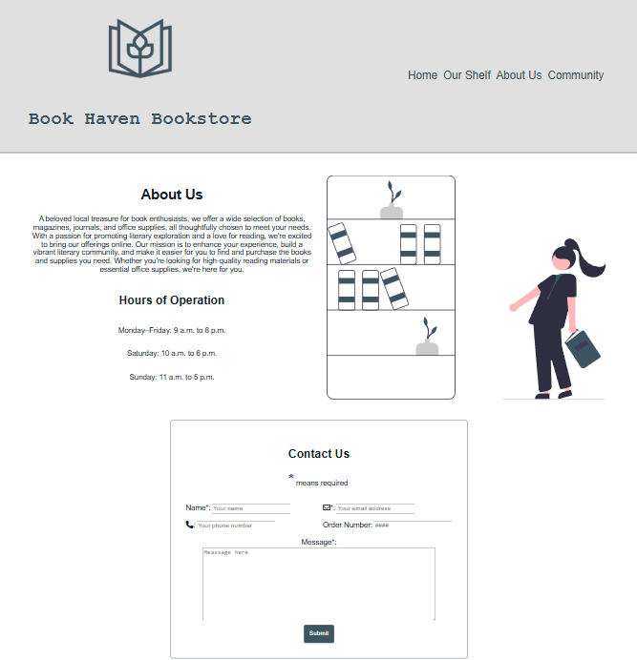

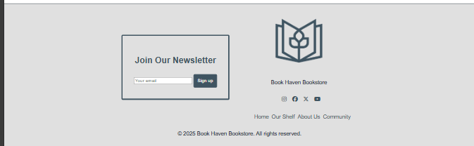

**Contact Us form:**

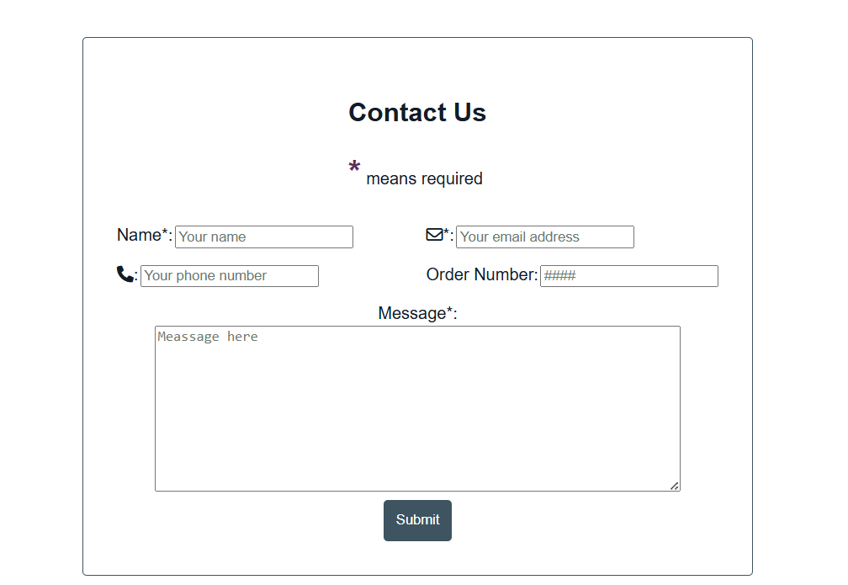

**LocalStorage—after form submission:**

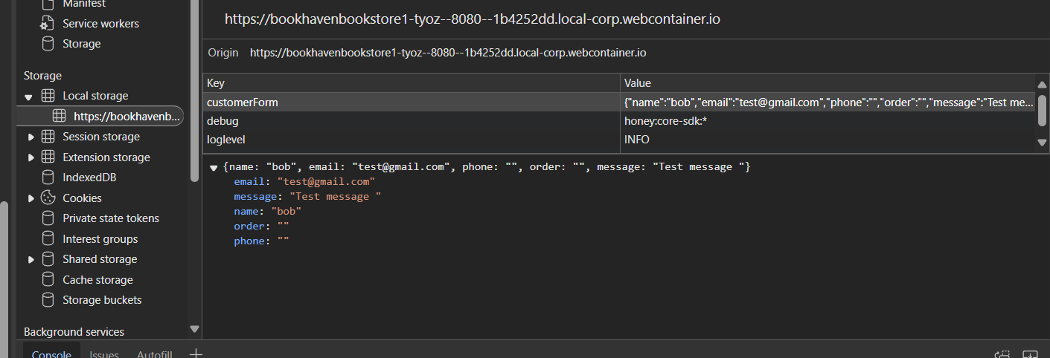

**Contact Us form—input validation:**

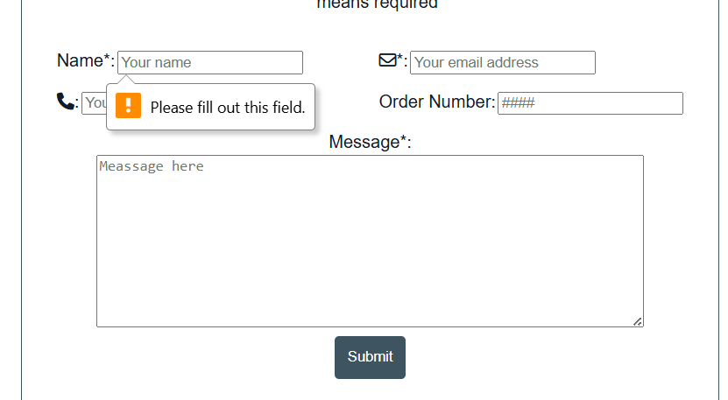

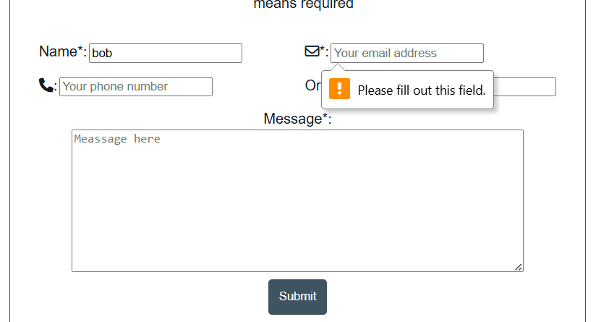

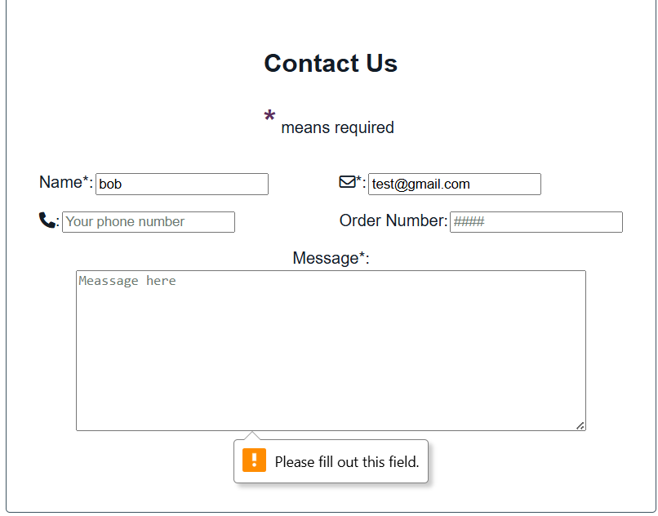

1. **Custom Page**

<Include the screenshot(s) for the custom page>

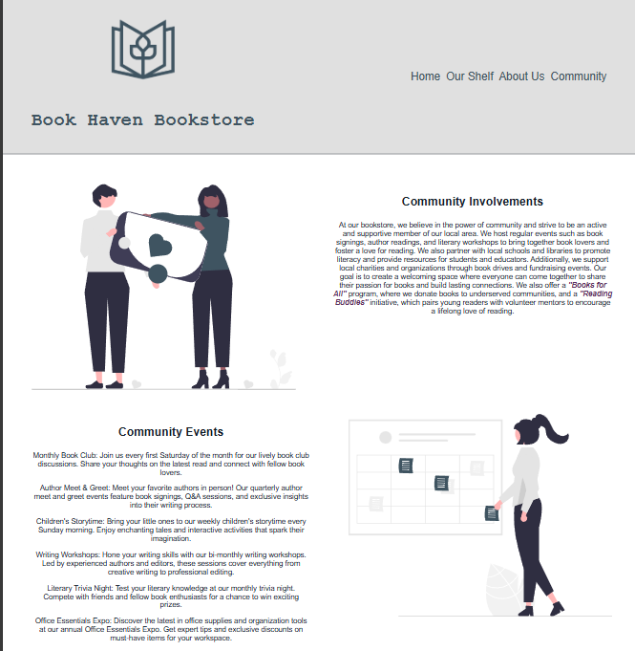

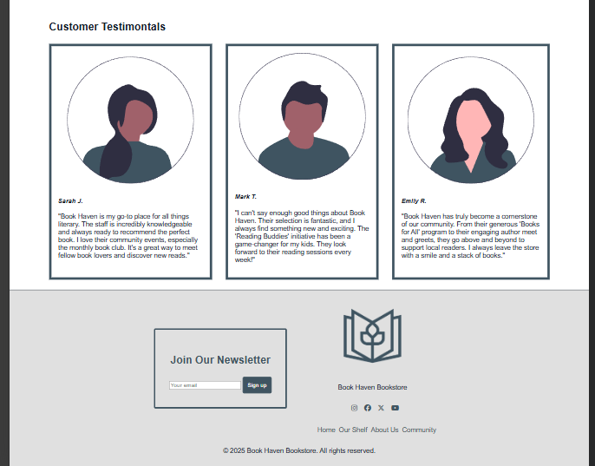

# Description of Issues

<include screenshots or paste code below and provide a description of issue>

HTML Issue: When I click the link, I got an error message “404” and here is the piece of the code”<a href="/About" class="nav_link ">About Us</a>”. *I look over my notes and the lesson to see what I was doing wrong. I type in the wrong thing to link it. This is how I fixed the code “*<a href="About.html" class="nav_link ">About Us</a>”.

CSS Issue: social media links was not center property. I added margin to push more to the left.

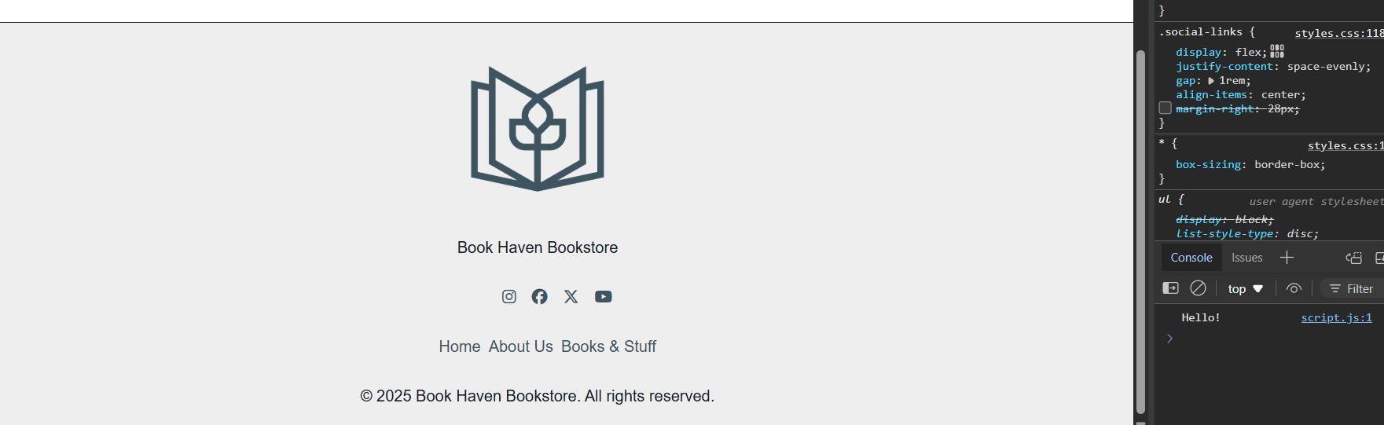

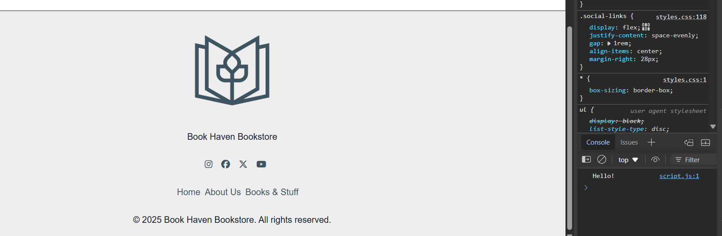

JavaScript issue:

I wasn’t able to have onClick be seen by the html. Console said this is undefined "<button type="button" onclick="viewCart()"><i class="fas fa-shopping-cart"></i></button>".

*In Html :* <script defer type=”module”  src="script.js"></script>

I remove the module type because it used to indicate that the script should be treated as a JavaScript module with the use import and export which I am only using one script of this project. This made the Onclick worked fine.